

**AI-TIME TABLE GENERATOR**

**A PROJECT REPORT**

***Submitted by***

|  |  |
| --- | --- |
| **NITHIN PRITHIV J** | **(512220104023)** |
| **ROGITH A** | **(512220104027)** |

***Pursuing pre-final year of the degree***

**BACHELOR OF ENGINEERING**

**in**

**COMPUTER SCIENCE AND ENGINEERING**

**SKP ENGINEERING COLLEGE,**

**THIRUVANNAMALAI - 606611**



**MAY 2023**

**ANNA UNIVERSITY: CHENNAI 600 025**

**BONAFIDE CERTIFICATE**

Certified that CS8611- mini project report “**AI-TIME TABLE GENERATOR**

’’ is the bonafide work of “**J.NITHIN PRITHIV,A.ROGITH**” who carried out the project work under my supervision.

**SIGNATURE SIGNATURE**

**Dr N.PURUSHOTHAMAN M.E,Ph.D, Dr.V.RAJI, M.E.,Ph.D, HEAD OF THE DEPARTMENT, SUPERVISOR**

Department of Computer Science and Engineering,

S. K.P Engineering College, Thiruvannamalai - 606 611.

Department of Computer Science and Engineering,

S.K.P Engineering College Thiruvannamalai - 606 611.

The project report submitted for the viva-voce held on ………….

**INTERNAL EXAMINER EXTERNAL EXAMINER**

**ACKNOWLEDGEMENT**

I am very thankful to the management of SKP Engineering College, Thiruvannamalai for giving us this wonderful opportunity to study in this college and utilize all the facilities to the fullest.

We thank profusely **Mr.K.KARUNANITHI B.E., M.B.A.,** chairman of our college for envisioning and providing us with the harmonious atmosphere which is of at most necessity for this project work.

We thank to **Dr.S.BASKARAN,M.E., Ph.D.,** Principal of college for providing us the facilities to successfully carry out this project work.

No words of gratitude will suffice for the unquestioning support extended to us by our Head of the Department **Dr.N.PURUSHOTHAMAN,M.E., Ph.D.,** and Supervisor **Dr.V.RAJI,M.E., Ph.D.,** for being ever supporting force during our project work.

We also extend our thanks to our Class Adviser and every member of the faculty who provided valuable academic guidance, and their co-operation to do this successful project. Finally, we would like to thank our Parents, Friends, and all Teaching & Non-Teaching staff for their encouragement and enthusiastic co- operation.

#### Abstract

The AI-Time Table Generator is an innovative solution that leverages artificial intelligence to streamline and optimize the complex process of creating academic schedules. This system addresses the challenges faced by educational institutions in efficiently managing resources, meeting diverse preferences, and adapting to dynamic scheduling constraints. The generator utilizes machine learning algorithms to analyze historical data, student preferences, faculty availability, and room constraints. Through a user-friendly interface, administrators input various parameters, such as course requirements, faculty preferences, and break times. The AI algorithm then processes this information to generate an optimized timetable that minimizes conflicts and maximizes resource utilization.

This intelligent system not only considers traditional scheduling factors but also adapts to unforeseen circumstances, making it resilient to changes and disruptions. It incorporates a feedback loop, allowing users to provide input on generated schedules, refining the algorithm's performance over time. Additionally, the AI-Time Table Generator promotes fairness and equality by considering constraints such as workload distribution among faculty members and ensuring an equitable distribution of class times for students.

The system enhances collaboration and communication within educational institutions by providing a centralized platform for stakeholders to coordinate and share feedback. It offers real-time updates, allowing users to track changes and make informed decisions. The AI-Time Table Generator significantly reduces the manual effort and time required to create schedules, freeing up administrators to focus on more strategic aspects of academic planning.

Moreover, the system promotes sustainability by optimizing resource usage, minimizing travel time between classes, and reducing the need for paper-based scheduling. It adapts to varying academic structures and accommodates preferences for specific time slots or room allocations, enhancing overall satisfaction among students and faculty. The AI-Time Table Generator thus plays a pivotal role in enhancing the efficiency, flexibility, and fairness of academic scheduling processes, ultimately contributing to an improved educational experience for all stakeholders.

**Keywords** :

PYTHON, XLXS, XLWRITER, KIVY, CV2 Functional and Non-functional Requirements.

**TABLE OF CONTENTS**

|  |  |  |
| --- | --- | --- |
| **CHAPTER NO** | **TITLE** | **PAGE NO.** |
|  | **BONAFIDE CERTIFICATE** | ii |
|  | **ACKNOWLEDGEMENT** | iii |
|  | **ABSTRACT** | iv |
|  | **TABLE OF CONTENT** | v |
|  | **LIST OF FIGURES** | viii |
|  | **LIST OF ABBREVATION** | ix |
| **1** | **INTRODUCTION**   * 1. Overview   2. Problem Identified      1. Artificial Intelligence (AI)      2. AI Based Assistive Technology   1.3Objectives | 1  3  3  5  6 |
| **2** | **LITERATURE SURVEY** | 8 |
| **3** | **SYSTEM ANALYSIS** |  |
|  | 3.1 Exiting System | 12 |
|  | 3.1.1Disadvantages | 13 |
|  | 3.2 Proposed System | 14 |
|  | 3.2.1Advantages | 15 |
|  |  |  |
| **4** | **SYSTEM SPECIFICATION** |  |
|  | 4.1 Hardware Requirement | 17 |
|  | 4.2 Software Requirement | 17 |
|  | 4.3 Software Description | 17 |
| **5** | **ARCHITECTURE DIAGRAM**  5.1 System Architecture | 23 |
| **6** | **UML DIAGRAMS** |  |
|  | 6.1 Data Flow Diagram | 26 |
|  | 6.2 Use Case Diagram | 27 |
|  | 6.3 Class Diagram | 28 |
|  | 6.4 Activity Diagram | 29 |
|  | 6.5 Sequence Diagram | 30 |
|  | 6.6 Component Diagram | 31 |
|  | 6.7 Deployment Diagram | 32 |
|  |  |  |
| **7** | **SYSTEM IMPLEMENTATION** | 30 |
|  | 7.1 List of Modules | 34 |
|  | 7.2 Modules Description | 34 |
| **8** | **SYSTEM TESTING**  8.1 Unit Testing  8.2 System Testing  8.3 Valitation Testing  8.4 Integration Testing | 38  39  41  42 |
| **9** | **CODING**  9.1 Source Code  9.2 Output | 44  46 |
| **10**  **11** | **CONCLUSION**  **REFERENCE** | 50  51 |
|  |  |  |
|  |  |  |

|  |  |  |
| --- | --- | --- |
| **FIGURES** | **FIGURES NAME** | **PAGE NO** |
| Figure 5.1.1 | System Architecture | 23 |
| Figure 6.1.1 | DFD Diagrams | 26 |
| Figure 6.2.1 | Use Case diagram | 27 |
| Figure 6.3.1 | Class diagram | 28 |
| Figure 6.4.1 | Activity diagram | 29 |
| Figure 6.5.1 | Sequence diagram | 30 |
| Figure 6.6.1 | Component diagram | 31 |
| Figure 6.7.1 | Deployment diagram | 32 |

**LIST OF FIGURES**

|  |  |
| --- | --- |
| **ACRONYM** | **ABBREVIATION** |
| FRCNN | Faster Region-Convolutional Neural Network |
| WHO | World Health Organization |
| CNN | Convolutional Neural Networks |
| CV | Computer Version |
| AI | Artificial Intelligence |
| ML | Machine learning |
| DL | Deep Learning |
| HOG | Histogram of Oriented Gradient |
| SSD | Single Shot Detector |
| ANN | Artificial Neural Network |

**LIST OF ABBREVIATION**

**CHAPTER 1**

**INTRODUCTION**

* 1. **OVERVIEW:**

AI-TIME TABLE GENERATOR is an innovative tool designed to automate the process of creating efficient and optimized schedules for educational institutions. Leveraging the power of artificial intelligence, this system revolutionizes the traditional manual timetable creation process, ensuring better resource utilization and minimizing conflicts. The generator takes into account various constraints, such as teacher availability, classroom capacity, and subject requirements, to produce a well-structured timetable that meets the diverse needs of both educators and students.

Using advanced algorithms, the AI-TIME TABLE GENERATOR analyzes a plethora of input data, including teacher preferences, subject priorities, and student groupings. It intelligently balances the distribution of classes throughout the week, considering factors like class durations and breaks. This ensures a fair and equitable distribution of resources, preventing overloading of certain teachers or classrooms.

The system is highly adaptable and can accommodate last-minute changes or adjustments in the schedule. It also incorporates machine learning capabilities, learning from past scheduling patterns and continuously improving its optimization algorithms over time. This adaptive learning feature enhances the accuracy and efficiency of timetable generation, making it a valuable asset for educational institutions seeking to streamline their administrative processes.Moreover, the AI-TIME TABLE GENERATOR offers a user-friendly interface, allowing administrators to input relevant data easily and visualize the generated timetable. The system provides insights into resource utilization, helping institutions identify areas for improvement and optimization. Additionally, it facilitates collaboration among different departments or schools within an institution, fostering a cohesive and well-coordinated educational environment.

By automating the tedious task of timetable creation, the AI-TIME TABLE GENERATOR frees up valuable time for educators and administrators to focus on more strategic and impactful aspects of school management. Its ability to create balanced, conflict-free schedules contributes to a smoother learning experience for students, as they can access their classes without disruptions or inconveniences.

The AI-TIME TABLE GENERATOR is a cutting-edge solution that harnesses the capabilities of artificial intelligence to revolutionize the creation of educational schedules. With its adaptability, efficiency, and user-friendly interface, it emerges as a crucial tool for educational institutions striving for optimal resource utilization and a seamless academic experience.

* 1. **PROBLEM IDENTIFIED**

The AI- timetable generator faces several challenges, collectively constituting a significant problem. Firstly, the accuracy of input data is crucial, and any discrepancies or incomplete information may lead to flawed schedules. The system's dependency on historical data and predefined patterns may hinder its adaptability to dynamic scheduling requirements, resulting in suboptimal timetables. Additionally, the lack of real-time data integration poses a challenge, as sudden changes or new constraints may not be promptly reflected in generated schedules.

The complexity of incorporating various constraints, such as teacher preferences, room availability, and student course requirements, further complicates the algorithm. Balancing these constraints while optimizing for efficiency and fairness remains a delicate task. Moreover, the interpretability of the AI model's decision-making process is crucial for user acceptance, and the black-box nature of some models may hinder trust and transparency.

The AI timetable generator also grapples with scalability concerns, particularly in large educational institutions, where the number of variables and constraints exponentially increases. This can lead to extended computation times and resource-intensive processes. Addressing fairness and equity in timetable allocation, ensuring diverse course offerings, and accommodating special needs or preferences adds another layer of complexity.

Furthermore, the need for ongoing system updates and adaptations to evolving educational policies, curricula, and organizational structures poses a continuous challenge. The lack of a feedback loop for evaluating the effectiveness of generated timetables and iteratively improving the system impedes its ability to learn and adapt over time.

**1.2.1 ARTIFICIAL INTELLIGENCE (AI)**

Artificial Intelligence (AI) is a branch of computer science that deals with the creation of intelligent machines that can perform tasks that typically require human intelligence, such as learning, reasoning, problem-solving, perception, and natural language processing. The goal of AI is to create machines that can perform tasks autonomously, without the need for human intervention.

AI has its roots in the mid-20th century, when the first computer programs were developed that could simulate human thought processes. In the 1950s, AI research was formally established as a field of study, and researchers began to develop algorithms and models that could be used to create intelligent machines.

Over the years, AI has evolved significantly, and today, it is a rapidly growing field that is transforming many industries, including healthcare, finance, transportation, and manufacturing. AI has the potential to revolutionize the way we live, work, and interact with technology.

There are several types of AI, including:

1. **Reactive Machines**: These are the simplest type of AI systems that can only react to the present situation. They cannot store any memory or past experience, and they do not have the ability to use past experiences to inform future decisions.

2. **Limited Memory**: These AI systems can use past experiences to inform future decisions. They can store limited amounts of past data, but they cannot learn from it.

3. **Theory of Mind**: These AI systems have the ability to understand the emotions, beliefs, and intentions of other people. They can use this information to interact with humans more effectively.

4. **Self-Aware**: These are the most advanced type of AI systems that have the ability to understand their own emotions, beliefs, and intentions. They can use this information to improve their own performance and make decisions more effectively.

Deep learning is a subset of AI that involves training neural networks to learn from large datasets. It is used to solve complex problems such as image recognition, natural language processing, and autonomous driving. Deep learning algorithms can learn from data without being explicitly programmed, and they can make predictions and decisions based on that data.

In conclusion, AI is a rapidly growing field that has the potential to revolutionize the way we live and work. It is a complex and diverse field that encompasses many different subfields, including machine learning, deep learning, and natural language processing. With continued research and development, AI has the potential to transform many industries and solve some of the world's most complex problems.

* + 1. **AI BASED ASSISTIVE TECHNOLOGY**

An AI-based assistive technology for COVID-19 detection from lung X-ray using deep learning can be a very useful tool for early detection and treatment of COVID-19. Here are some steps that can be followed to develop such a technology:

1. **Data Collection**: A large dataset of lung X-rays that includes both COVID-19 positive and negative cases should be collected. This dataset can be obtained from hospitals, clinics, and research institutions that are actively involved in COVID-19 research.

2**. Preprocessing**: The collected lung X-rays should be preprocessed by removing any artifacts, noise, or irrelevant information. This can be done using image processing techniques such as noise reduction, image enhancement, and normalization.

3. **Feature Extraction**: Relevant features should be extracted from the preprocessed images using deep learning techniques such as convolutional neural networks (CNNs). These features can be used to distinguish between COVID-19 positive and negative cases.

4**. Model Training**: A CNN model should be trained using the extracted features. The model can be trained using supervised learning techniques with labeled data.

5. **Model Evaluation**: The trained model should be evaluated using a separate test dataset to measure its performance in detecting COVID-19 from lung X-rays. The model's accuracy, sensitivity, specificity, and F1 score should be calculated.

6. **Integration**: The trained model can be integrated into an AI-based assistive technology that can be used by healthcare professionals to detect COVID-19 from lung X-rays. The technology can be designed as a web or mobile application that allows healthcare professionals to upload lung X-rays and obtain the COVID-19 detection results in real-time.

AI-based assistive technology for COVID-19 detection from lung X-ray using deep learning has the potential to be a powerful tool in the fight against COVID-19. It can help in early detection and treatment of COVID-19, which can significantly reduce the spread of the virus and save lives.

**1.3 OBJECTIVES**

The AI-based timetable generator aims to streamline and optimize the scheduling process by leveraging advanced algorithms and artificial intelligence. Its primary objectives include:

1. **Efficiency Improvement:** Automate the time-consuming and complex task of timetable creation to enhance overall efficiency in educational institutions.

2. **Resource Optimization:** Ensure optimal utilization of available resources, such as classrooms, faculty, and time slots, to minimize conflicts and maximize productivity.

3**. Flexibility and Adaptability:**  Provide a flexible and adaptable scheduling system that can accommodate dynamic changes in course offerings, faculty availability, and student preferences.

4. **Conflict Resolution:** Identify and resolve scheduling conflicts, such as overlapping classes or resource constraints, to create a balanced and feasible timetable.

5. **Fair Distribution:** Ensure fair distribution of classes and resources among faculty members, avoiding instances of overburdening or underutilization.

6. **Customization:** Allow users to set preferences and constraints, enabling the customization of timetables based on specific institutional requirements and policies.

7. **User-Friendly Interface:** Offer an intuitive and user-friendly interface for easy interaction, allowing users to input data, view generated timetables, and make adjustments as needed.

8. **Time and Cost Savings:** Reduce the time and effort traditionally spent on manual timetable creation, leading to cost savings for educational institutions.

9. **Data Accuracy:** Minimize errors and inaccuracies in scheduling by utilizing AI algorithms to analyze data and generate timetables with a high degree of precision.

10. **Enhanced Student Experience:** Contribute to an improved learning experience by providing students with well-organized and optimized timetables that align with their academic needs and preferences.

**CHAPTER 2**

**LITERATURE SURVEY**

**2.1 SCALABLE DEPLOYMENT OF AI TIME-SERIES MODELS FOR IOT**

**Authors:** Bradley Eck

**Year:**2019

**Objective:**

The aim of this project is to create a scalable deployment of ai time-series models for iot .

**Methodology:**

IBM Research Castor, a cloud-native system for managing and deploying large numbers of AI timeseries models in IoT applications, is described. Modelling code templates, in Python and R, following a typical machine-learning workflow are supported. A knowledge-based approach to managing model and time-series data allows the use of general semantic concepts for expressing feature engineering tasks. Model templates can be programmatically deployed against specific instances of semantic concepts, thus supporting model reuse and automated replication as the IoT application grows. Deployed models are automatically executed in parallel leveraging a serverless cloud computing framework. The complete history of trained model versions and rolling-horizon predictions is persisted, thus enabling full model lineage and traceability.

**Merits:**

* Its accuracy is high.
* It is efficient and time consuming is low.

**Demerits:**

* The accuracy is very low.

**2.2 AI MODELLING AND TIME-SERIES**

**Authors:** Francesco Fusco, Robert Gormally, Mark Purcell

**Year:**2020

**Objective:**

The aim of this project is to create a AI Modelling and Time-series .

**Methodology:**

We developed a distribution-grid observability and management system (DOMS) to provide decision-support to energy utilities for the prediction of localised congestion events and their management, by trading energy flexibility resources. The solution builds on a sensor data-driven model of the grid, based on probabilistic graphs [3, 4]. Spatio-temporal relationships between grid quantities are modelled with combinations of noisy sensor models and latent-variable neural networks, respectively defining the conditional and joint gaussian distributions of a factor graph. When energy forecasts are received (see Section 3), inference on the graph provides predictions of all the variables represented in the grid model. If variable predictions are outside desired operational ranges, inference on the graph produces estimates of the amount and location of energy flexibility required in order to maintain desired operation.

# **2.3 DEEP LEARNING-BASED SECURE DATA ANALYTIC FRAMEWORK FOR SMART GRID SYSTEMS**

**Authors:** [Aparna Kumari](https://ieeexplore.ieee.org/author/37086887086), [Darshan Vekaria](https://ieeexplore.ieee.org/author/37086875758), [Rajesh Gupta](https://ieeexplore.ieee.org/author/37272679300)

**Year:**2021

**Objective:**

The aim of this project is to create a deep learning-based secure data analytic framework for smart grid systems.

**Methodology:**

With the increasing demand for electricity and the smart grids (SG) systems, it becomes essential for them to realize the need for accurate energy demand at the demand response management (DRM). It directly impacts the consumer's lifestyle and also helps to reduce the electricity bill. Motivated from these facts, This paper proposes a priority analyzer to determine energy usage in the best time-slots. By employing a time-of-use (ToU) based data analytic approach, this paper predicts energy load expectation and gives analysis for the economical use of electrical appliances to reduce bills (Redills). The Redills offers a solution to the requirements of the user to save energy at the demand side and reduce energy production at the supply side of the DRM system. Redills accurately predicts the future load consumption based on the historical data using deep learning (DL)-based LSTM model, and then passes the prediction to the priority analyzer system to generate the monthly and season based priority list of ToU. Based on the time-slot priority list, the consumer can use the devices in the effective time slots for the economical use of the appliance. The simulation results show that Redills predicts energy consumption more accurately as compared to the state-of-art approaches.

**2.4 AI TIME-SERIES MODELS**

**Authors:** Francesco Fusco , Robert Gormally , Mark Purcell

**Year:**2021

**Objective:**

The aim of this project is to create a AI time-series models.

**Methodology:**

Creating an AI model for use on IBM Reserach Castor involves two separate steps of implementing the functionality itself and deploying the model by specifying the parameters that control its execution. In the following, Section 3.1 details the model implementation, based on a typical machinelearning workflow of load, transform, train and score. Section 3.2 discusses model deployment, where a model implementation is associated with a specific semantic context and other configuration governing when and how the model should be executed. Separation between model implementation and deployment configuration is a key aspect of the system, designed to enable reuse and programmatic deployment of AI. The model implementation is quite flexible and can be used to carry out any other desired data processing tasks besides machine-learning time-series prediction. For example, in several deployments of our system, as shown in Section 4.1, models perform data transformations such as creating regular energy time-series from integration and resampling of an irregular, instantaneous current or power data feed.

**CHAPTER 3**

**SYSTEM ANALYSIS**

**3.1 EXISTING SYSTEM:**

As of my last knowledge update in January 2022, I don't have specific details about every existing AI-based timetable generator, as new systems and updates may have been developed since then. However, I can provide a general overview of how AI-based timetable generators typically work and some common features they may have.

1. **Data Input:** - The system typically takes input data, including information about available resources (rooms, teachers, equipment), courses to be scheduled, and any constraints or preferences.

2. **Constraints and Preferences:** - The system considers various constraints such as room availability, teacher preferences, and any special requirements for certain courses or activities.

3. **Optimization Algorithms:** - AI-based timetable generators often use optimization algorithms to find the best possible schedule that satisfies all constraints and preferences. Common algorithms include genetic algorithms, simulated annealing, or constraint satisfaction problem (CSP) solvers.

4. **Machine Learning:** - Some systems may incorporate machine learning techniques to continuously improve scheduling decisions based on past data and user feedback. For example, the system might learn from historical data which time slots are most suitable for specific courses or which rooms are frequently requested.

5. **User Interface:** - The system usually provides a user-friendly interface for administrators or scheduling coordinators to input data, set preferences, and review or modify the generated schedules.

6. **Real-time Updates:** - Some advanced systems may allow real-time updates to the timetable based on changes in resource availability, unexpected events, or other dynamic factors.

7. **Conflict Resolution:** - The system should have mechanisms to detect and resolve conflicts that may arise during the scheduling process, such as overlapping classes or resource double-booking.

8. **Reporting and Visualization:** - Generated timetables can be presented in a visually appealing format, and the system may provide reports on resource utilization, adherence to preferences, and other relevant metrics.

9. **Integration with Other Systems:** - Timetable generators may integrate with other academic systems, such as student information systems, to ensure consistency and coherence in the overall educational workflow.

10. **Scalability:** - The system should be scalable to handle different institutions, departments, or schools with varying complexities and requirements.

It's advisable to check the documentation or contact the providers of specific AI timetable generators for the most up-to-date and accurate information about their features and functionalities. Additionally, advancements in AI and scheduling systems may have occurred since my last update.

**3.1.1 DISADVANTAGES:**.

* Initial Setup Complexity: - Implementing an AI-powered timetable generator can be complex and time-consuming initially. Integrating the system into existing infrastructure may require significant effort and resources.
* Data Dependency: - The accuracy and effectiveness of the AI timetable generator heavily depend on the quality of input data. If the input data is inaccurate, outdated, or incomplete, it may result in suboptimal timetables.
* Lack of Human Touch: - AI systems may lack the human touch and understanding of unique circumstances. Timetables generated solely by AI might overlook specific nuances or preferences that humans consider important, leading to dissatisfaction among stakeholders.
* Resistance to Change: - Educational institutions or organizations may face resistance from staff or stakeholders who are not comfortable with the shift to AI-generated timetables. Overcoming this resistance and ensuring user acceptance can be a challenge.
* Unforeseen Constraints:- AI algorithms may not always account for unforeseen constraints or last-minute changes. Sudden events, such as a faculty member falling ill or a room becoming unavailable, may require manual intervention to adjust the timetable.

**3.2 PROPOSED SYSTEM:**

Designing an AI-based timetable generator involves several key components to ensure efficiency, accuracy, and user-friendliness. Here's a proposed system outline for an AI-driven timetable generator:

* User Interface (UI): - Registration and Login: Allow users, such as administrators, teachers, and students, to register and log in to the system.
* Dashboard: Provide an intuitive dashboard displaying relevant options and information.
* Input Module: - Course Information: Collect details about courses, including course codes, names, and credit hours.
* Teacher Information: Gather data on teachers, including their availability, preferences, and expertise.
* Classroom Information: Input details about available classrooms, such as capacity and facilities
* Data Processing - Data Validation: Ensure the accuracy and consistency of input data, checking for errors or conflicts.
* Generation of Timetable: - Initial Population: Create an initial set of timetables based on the input data.
* Crossover and Mutation: Apply genetic operators or other relevant methods for creating new timetable variations.
* Evaluation: Assess the fitness of each timetable based on optimization criteria.

**3.2.1 ADVANTAGES:**

* Optimized Resource Utilization: AI-powered timetable generators can analyze a vast amount of data, including teacher availability, classroom capacity, and subject requirements. This enables the system to create schedules that efficiently allocate resources, minimizing conflicts and ensuring optimal use of available resources.
* Time Efficiency: With the ability to process information rapidly, AI timetable generators significantly reduce the time required to create schedules. This efficiency is particularly beneficial in educational institutions with complex scheduling requirements, as it frees up administrative staff to focus on other important tasks.
* Adaptability and Flexibility: AI algorithms can easily adapt to changes and unexpected events. If there are alterations to teacher availability, class sizes, or other scheduling constraints, the AI-powered system can quickly readjust the timetable to accommodate these changes without causing major disruptions.
* Conflict Resolution: AI timetable generators excel at identifying and resolving scheduling conflicts. By considering various constraints simultaneously, such as teacher preferences, student preferences, and room availability, the system can create schedules that minimize conflicts and improve overall satisfaction among stakeholders.
* Data-Driven Decision Making: AI systems can analyze historical data and usage patterns to make informed decisions about scheduling. This data-driven approach helps in creating timetables that align with the preferences and requirements of teachers, students, and administrators, leading to a more effective and satisfactory scheduling process.

**CHAPTER 4**

**SYSTEM SPECIFICATION**

**4.1 HARDWARE REQUIREMENT:**

* Processor : Intel Core i3 or Higher/AMD Processors
* RAM : 4GB or Higher(Recommended)
* Hard Disk : 50GB or Higher(Recommended)

**4.2 SOFTWARE REQUIREMENT:**

* Operating System : Windows 7 or Higher
* Coding Language : python 3.8.4
* Software Using : python-kivy, Xlxs, Xlwriter, Pandas
* BC DLL : PyChain, Node Package Manager
* Editor : VS Code / Anyother Text Editor

**4.3 SOFTWARE DESCRIPTION:**

**Python 3.8.4**

Python is a general-purpose interpreted, interactive, object-oriented, and high-level programming language. It was created by Guido van Rossum during 1985- 1990. Like Perl, Python source code is also available under the GNU General Public License (GPL). This tutorial gives enough understanding on Python programming language.

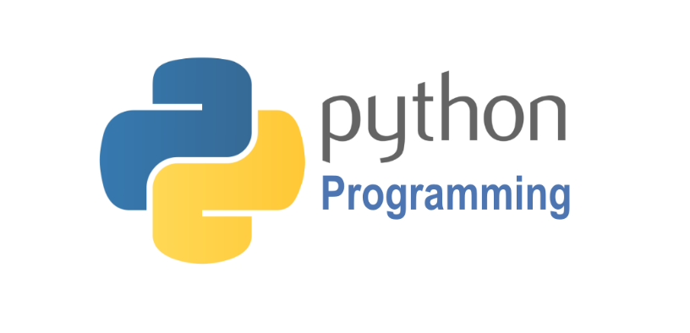

Python is a high-level, interpreted, interactive and object-oriented scripting language. Python is designed to be highly readable. It uses English keywords frequently where as other languages use punctuation, and it has fewer syntactical constructions than other languages. Python is a MUST for students and working professionals to become a great Software Engineer specially when they are working in Web Development Domain.

Python is currently the most widely used multi-purpose, high-level programming language. Python allows programming in Object-Oriented and Procedural paradigms. Python programs generally are smaller than other programming languages like Java. Programmers have to type relatively less and indentation requirement of the language, makes them readable all the time. Python language is being used by almost all tech-giant companies like – Google, Amazon, Facebook, Instagram, Dropbox, Uber… etc. The biggest strength of Python is huge collection of standard libraries which can be used for the following:

* Machine Learning
* GUI Applications (like Kivy, Tkinter, PyQt etc.)
* Web frameworks like Django (used by YouTube, Instagram, Dropbox)
* Image processing (like OpenCV, Pillow)
* Web scraping (like Scrapy, Beautiful Soup, Selenium)
* Test frameworks
* Multimedia
* Scientific computing
* Text processing and many more.

**NLTK**

NLTK is a leading platform for building Python programs to work with human language data. It provides easy-to-use interfaces to over 50 corpora and lexical resources such as WordNet, along with a suite of text processing libraries for classification, tokenization, stemming, tagging, parsing, and semantic reasoning, wrappers for industrial-strength NLP libraries, and an active discussion forum.

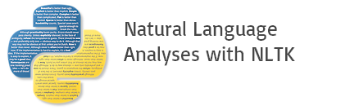

NLTK (Natural Language Toolkit) Library is a suite that contains libraries and programs for statistical language processing. It is one of the most powerful NLP libraries, which contains packages to make machines understand human language and reply to it with an appropriate response.

**XLXS:**

XLSX files are spreadsheet file formats from Microsoft Corporation which is used to enter and store data and, also for calculation. In Microsoft Excel (2007/2010/), xlsx files are used to store spreadsheets and workbooks. In python data from this file format can be read and also exported. Excel and Python both are widely used as part of data analytics and data science projects. In this article, we shall cover how to read and write data in excel files from python.



Whether you are a student or a working professional, chances are that you have used Excel to work with data and crunch numbers.

In fact, research in 2019 found that roughly [54% of businesses](https://www.mooc.org/blog/how-important-is-excel-in-business) use Excel to perform arithmetic operations, analyze data, create visualizations, and generate reports. You can also perform predictive modeling tasks like regression and clustering using Excel.

One limitation of Excel is its inability to handle large amounts of data. You can run into serious performance issues when trying to perform complex operations on a lot of data entries in Excel, especially if your formulas and macros are not optimized for performance.

Excel can also become very time-consuming if you need to perform repetitive tasks. For instance, if you need to replicate an analysis on multiple Excel files every week, you would have to open them manually and copy-paste the same formulas over and over.

Surveys show that [93% of Excel users](https://www.caspio.com/blog/excel-data-management-problems/) find it time-consuming to consolidate spreadsheets and that employees spend approximately 12 hours each month just combining different Excel files. These drawbacks can be solved by automating Excel workflows with Python. Tasks like spreadsheet consolidation, data cleaning, and predictive modeling can be done in minutes using a simple Python script that writes to an Excel file.

Excel users can also create a scheduler in Python that runs the script automatically at different time intervals, dramatically reducing the amount of human intervention required to perform the same task again and again.

In this article, we will show you how to:

* Use a library called Openpyxl to read and write Excel files using Python
* Create arithmetic operations and Excel formulas in Python
* Manipulate Excel worksheets using Python
* Build visualizations in Python and save them to an Excel file
* Format Excel cell colors and styles using Python

**PYTHON-KIVY:**

**Kivy** is a [free](https://en.wikipedia.org/wiki/Free_Software) and [open source](https://en.wikipedia.org/wiki/Open_Source_Software) [Python](https://en.wikipedia.org/wiki/Python_(programming_language)) [framework](https://en.wikipedia.org/wiki/Application_framework) for developing [mobile apps](https://en.wikipedia.org/wiki/Mobile_app) and other [multitouch](https://en.wikipedia.org/wiki/Multitouch) [application software](https://en.wikipedia.org/wiki/Application_software) with a [natural user interface (NUI)](https://en.wikipedia.org/wiki/Natural_User_Interface). It is distributed under the terms of the [MIT License](https://en.wikipedia.org/wiki/MIT_License), and can run on [Android](https://en.wikipedia.org/wiki/Android_(operating_system)), [iOS](https://en.wikipedia.org/wiki/IOS), [Linux](https://en.wikipedia.org/wiki/Linux), [macOS](https://en.wikipedia.org/wiki/MacOS), and [Windows](https://en.wikipedia.org/wiki/Microsoft_Windows).



Kivy is the main framework developed by the Kivy organization,[[3]](https://en.wikipedia.org/wiki/Kivy_(framework)#cite_note-3) alongside Python for Android,[[4]](https://en.wikipedia.org/wiki/Kivy_(framework)#cite_note-4) Kivy iOS,[[5]](https://en.wikipedia.org/wiki/Kivy_(framework)#cite_note-5) and several other libraries meant to be used on all platforms. In 2012, Kivy got a $5000 grant from the [Python Software Foundation](https://en.wikipedia.org/wiki/Python_Software_Foundation) for porting it to Python 3.3.[[6]](https://en.wikipedia.org/wiki/Kivy_(framework)#cite_note-6) Kivy also supports the [Raspberry Pi](https://en.wikipedia.org/wiki/Raspberry_Pi) which was funded through [Bountysource](https://en.wikipedia.org/wiki/Bountysource" \o "Bountysource).[[7]](https://en.wikipedia.org/wiki/Kivy_(framework)#cite_note-7)

The framework contains all the elements for building an application such as:

* extensive input support for [mouse](https://en.wikipedia.org/wiki/Computer_mouse), [keyboard](https://en.wikipedia.org/wiki/Computer_keyboard), [TUIO](https://en.wikipedia.org/wiki/TUIO), and OS-specific multitouch events;
* a graphic library using only [OpenGL ES 2](https://en.wikipedia.org/wiki/OpenGL_ES), and based on [Vertex Buffer Object](https://en.wikipedia.org/wiki/Vertex_Buffer_Object) and [shaders](https://en.wikipedia.org/wiki/Shader);
* a wide range of [widgets](https://en.wikipedia.org/wiki/GUI_widget) that support multitouch;
* an intermediate language (Kv)[[8]](https://en.wikipedia.org/wiki/Kivy_(framework)#cite_note-8) used to easily design custom widgets.

**CHAPTER 6**

**ARCHITECTURE DIAGRAM**

**6 .1 SYSTEM ARCHITECTURE:**

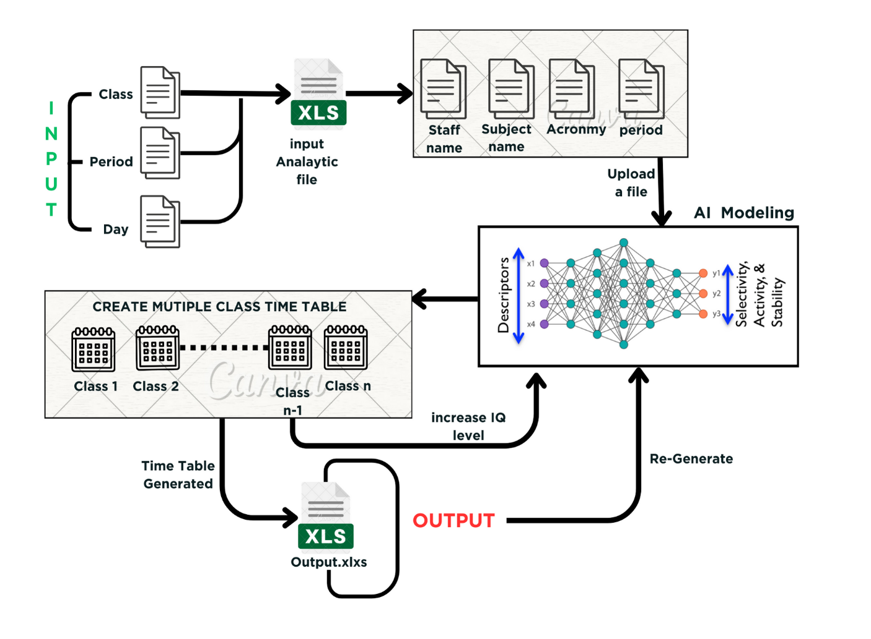

Figure 6.1.1

Here's a simplified representation of the architecture for an AI timetable generator:

**User Interface (UI):**

- Web Interface: Allows users (such as administrators, teachers, or students) to interact with the system.

- User Input: Accepts input parameters like course requirements, room availability, and teacher preferences.

**Frontend**:

- Presentation Layer: Manages the presentation logic, interacts with the backend, and handles user inputs and outputs.

**Backend:**

- Authentication and Authorization: Manages user authentication and authorization to ensure secure access.

- Input Validation: Validates user inputs to ensure data integrity and correctness.

**AI Engine:**

- Machine Learning Models: Uses machine learning algorithms to optimize the timetable generation based on various constraints and preferences.

- Training Module: Periodically updates and retrains the machine learning models using new data to improve accuracy.

**External Data Sources:**

- External APIs: Interfaces with external systems or databases for additional data, such as academic calendars, special events, or holidays.

**Timetable Generation:**

- Constraint Solver: Resolves conflicts and ensures that generated timetables meet specified constraints (room capacity, teacher availability, etc.).

- Optimization Algorithm: Optimizes the timetable based on predefined objectives, such as minimizing gaps, balancing teacher workload, or maximizing room utilization.

**Logging and Monitoring:**

- Logging Service: Records system activities, errors, and user interactions for monitoring and troubleshooting.

- Monitoring Tools: Monitors system performance, resource usage, and user interactions.

This architecture diagram provides a high-level overview of the key components and their interactions. The specific technologies, frameworks, and tools used would depend on the requirements and preferences of the development team.

**CHAPTER 6**

**UML DIAGRAMS**

**6.1 DATAFLOW DIAGRAM:**

A data flow diagram shows the way information flows through a process or system. It includes data inputs and outputs, data stores, and the various sub processes the data moves through. DFDs are built using standardized symbols and notation to describe various entities and their relationships.

Data Collection

Data Preproccessing

Training

Hyperparameter Tuning

Testing

Deployment

Integration

Figure 6.1.1

**6.2 Use Case Diagram:**

This Use Case Diagram is a graphic depiction of the interactions among the elements of AI time table generator. It represents the methodology used in system analysis to identify, clarify, and organize system requirements of AI time table generator.

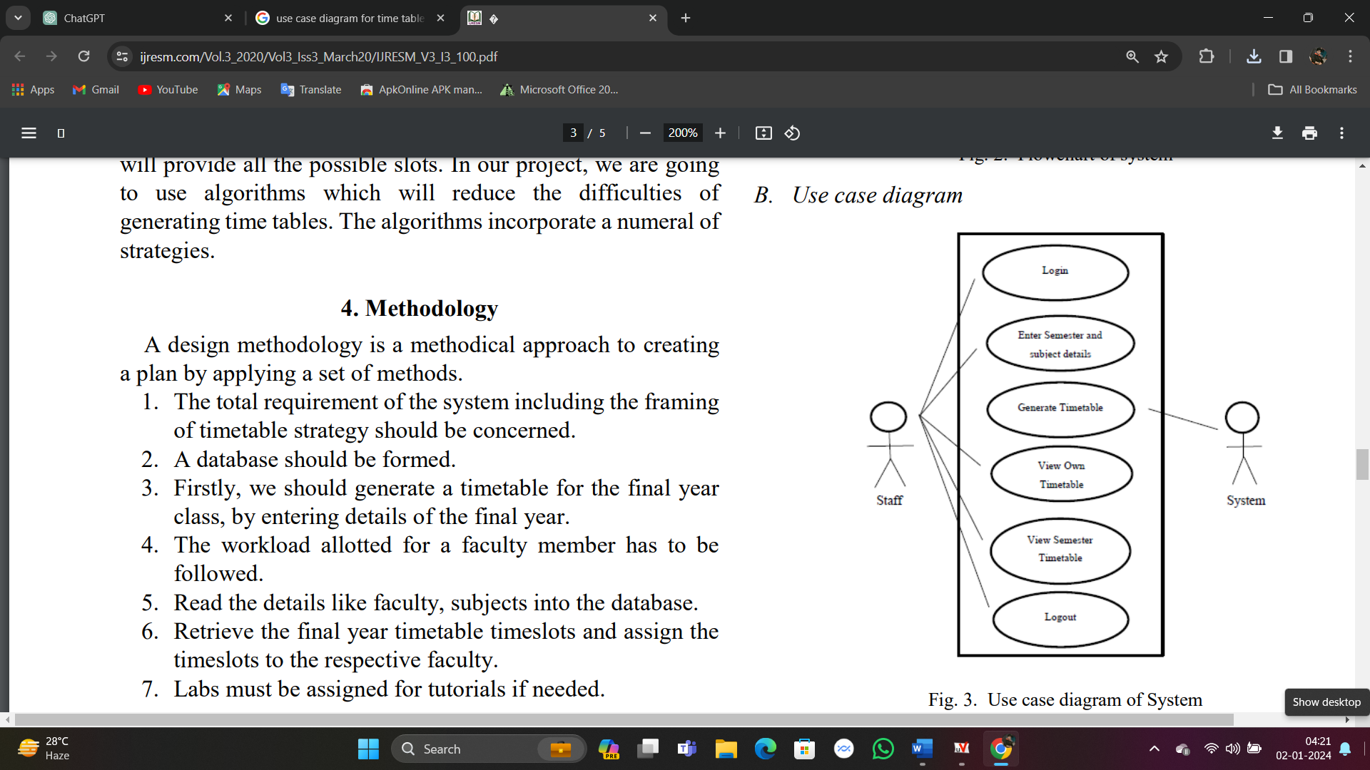

Figure 6.2.1

**6.3 Class Diagram:**

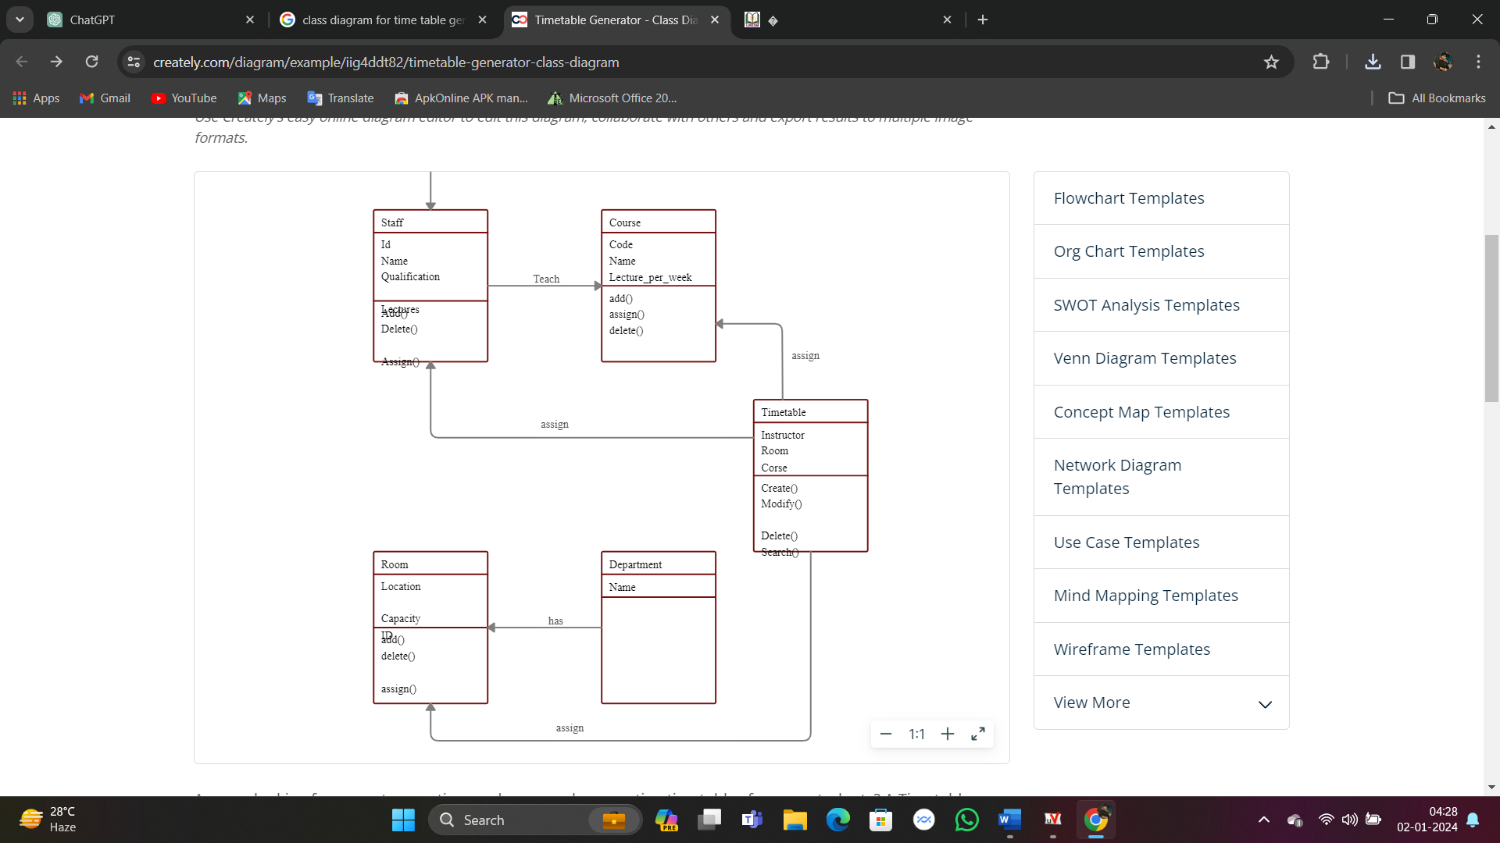

Figure 6.3.1

The Dataset class has a composition relationship with the Preprocessor class, as the preprocessor is responsible for preprocessing the dataset. The Preprocessor class has a composition relationship with the Deep Learning Model class, as the preprocessed images are used as inputs to the deep learning model during training, evaluation, and prediction.

This is a basic representation, and you may need to add more details based on the specific requirements of your AI timetable generator. Additionally, you might want to include classes for days of the week, time representations, and other relevant entities in your system.

**6.4 Activity Diagram:**

The activity diagram for the AI timetable generator begins with the initiation of the process, triggered by a start node. The first activity involves gathering input data, such as course requirements, faculty availability, and room constraints. This leads to a decision point where the system checks for any conflicts in the input data. If conflicts are detected, the process flows to an error handling activity; otherwise, it proceeds to the next step.

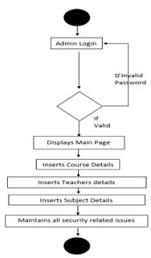

Figure 6.4.1

The AI then employs its scheduling algorithm, utilizing data analytics and optimization techniques to generate an initial timetable. This process is represented by an activity node. Subsequently, the diagram includes a loop to iteratively refine the timetable, accommodating any necessary adjustments based on user preferences, feedback, or unforeseen constraints.

Once the final timetable is generated, the diagram shows an activity node for outputting the timetable to the users. Additionally, there may be a feedback loop where users can provide input on the generated timetable, enabling continuous improvement in subsequent iterations.

**6.5 . Sequence Diagram:**

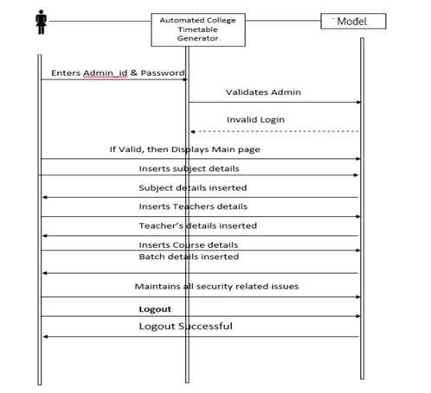

A sequence diagram is a type of interaction diagram that shows the interactions between objects or components in a system over time. In the case of an AI timetable generator, the sequence diagram can illustrate the flow of messages and interactions between different modules or components involved in the timetable generation process. Here's a brief 10-line paragraph describing a sequence diagram for an AI timetable generator, The sequence diagram begins with the initiation of the AI timetable generator, which receives input parameters such as the number of courses, available resources, and scheduling constraints. The first message is sent to the data processing module, which extracts relevant information from the input data. Subsequently, the control flow moves to the scheduling algorithm module, where the AI-driven algorithm processes the data and generates an initial timetable proposal.

The sequence diagram concludes with a message indicating the successful completion of the timetable generation process. This diagram provides a visual representation of the dynamic interactions between the various components, showcasing the iterative nature of the AI timetable generator as it refines the schedule based on user input and constraints.

**6.6 Component Diagram:**

A component diagram, also known as a UML component diagram, describes the organization and wiring of the physical components in a system.

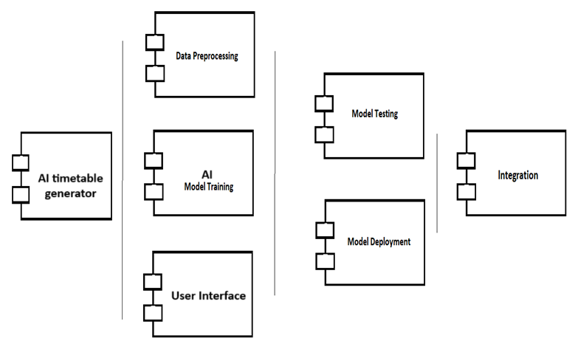Figure 7.6.1

The Component Diagram for an AI timetable generator system illustrates the interconnected components working collaboratively to automate and optimize the scheduling process, providing a user-friendly interface, efficient data storage, intelligent scheduling algorithms, and robust supporting modules for reporting, integration, security, and monitoring.

**6.7 Deployment Diagram:**

A deployment diagram is a UML diagram type that shows the execution architecture of a system, including nodes such as hardware or software execution environments, and the middleware connecting them.

AI time table generator API

AI time table generator

**HTTP**

Trained Model component

Preproccessing

component

**Preprocewss**

**HTTP**

Result Output component

User Interface

**HTTP**

Figure 6.7.1

The AI timetable generator's deployment diagram comprises three main components: the client devices, server, and database. Client devices, such as computers or mobile devices, interact with the system through a user interface. The server hosts the core AI algorithm responsible for timetable generation, utilizing processing power and memory resources. A web server facilitates communication between the client and server components, managing requests and responses. The database stores relevant data, including user preferences, course information, and generated timetables. A secure communication channel ensures data integrity during interactions between the client, server, and database. The AI algorithm may be distributed across multiple servers for scalability. Load balancers optimize resource distribution, enhancing system performance. Firewall and encryption mechanisms safeguard the system against unauthorized access and data breaches. Continuous monitoring tools and logging mechanisms enable administrators to track system health and address issues promptly, ensuring a reliable and efficient AI timetable generation process.

**CHAPTER 7**

**SYSTEM IMPLEMENTATION**

**7.1 LIST OF MODULES:**

* Data Input Module
* Preprocessing Module
* Constraint Handling Module
* Scheduling Algorithm
* User Interface Module
* Output Visualization Module
* Conflict Resolution Module
* Machine Learning Module
* Optimization Module
* Reporting Module
* Integration with Academic Management Systems
* Scalability Module
* Alerts and Notifications Module
* Mobile Compatibility Module
* APIs for Integration
* Security Module

**7.2 MODULES DESCRIPTION:**

**Data Input Module:**

- Responsible for collecting input data, including available resources, rooms, faculty availability, and student preferences.

**Preprocessing Module:**

- Clean and preprocess the input data to ensure consistency and accuracy.

**Constraint Handling Module:**

- Manage and enforce constraints such as room capacities, faculty preferences, and time slot restrictions.

**Scheduling Algorithm:**

- Implement an intelligent scheduling algorithm to optimize the timetable based on input data and constraints.

**User Interface Module:**

- Develop a user-friendly interface for users to input data, view generated timetables, and make adjustments.

**Output Visualization Module:**

- Display the generated timetable in a readable and understandable format for users, potentially using graphical representations.

**Conflict Resolution Module:**

- Identify and resolve conflicts that may arise during the timetable generation process.

**Machine Learning Module:**

- Implement machine learning algorithms to learn from past schedules and improve the efficiency of the timetable generation process over time.

**Optimization Module:**

- Continuously optimize the timetable based on feedback and changing requirements.

**Reporting Module:**

- Generate reports on the quality of the generated timetable, highlighting potential issues or areas for improvement.

**Integration with Academic Management Systems:**

- Connect with existing academic management systems to seamlessly integrate the generated timetable with other academic processes.

**Scalability Module:**

- Design the system to handle large datasets and scale efficiently as the size of the institution or complexity of scheduling requirements increases.

**Alerts and Notifications Module:**

- Notify users of important events, conflicts, or changes related to the timetable.

**Mobile Compatibility Module:**

- Ensure that the timetable generator is compatible with mobile devices for accessibility and convenience.

**APIs for Integration:**

- Provide APIs for easy integration with other tools and systems used in the educational institution

**Security Module:**

- Implement security measures to protect sensitive data and ensure the integrity of the timetable generation process.

**CHAPTER 8**

**SYSTEM TESTING**

**8.1 UNIT TESTING:**

Unit testing is a crucial aspect of software development, including the development of an AI timetable generator. Unit tests help ensure that individual components or units of code function as expected. Here are some guidelines and examples of how you might approach unit testing for an AI timetable generator:

**Identify Units of Code:**

- Break down your AI timetable generator into smaller units or functions. These could include modules responsible for data parsing, constraint checking, scheduling algorithms, and so on.

**Write Test Cases:**

- For each unit, write test cases that cover various scenarios. Consider edge cases, normal cases, and any potential error cases. For an AI timetable generator, you might test cases like:

- Valid input data.

- Invalid input data (e.g., missing data, conflicting constraints).

- Different combinations of constraints (e.g., room availability, teacher preferences).

- Ensure that the generated timetable satisfies all constraints.

**Use Testing Frameworks:**

- Choose a testing framework suitable for your programming language. For example, if you're using Python, you might use `unittest`, `pytest`, or another framework.

**Isolate Dependencies:**

- Ensure that the unit being tested is isolated from external dependencies or services. You can use mocks or stubs for external services to simulate their behavior.

**Automation:**

- Automate your tests so they can be easily run whenever changes are made to the codebase. Continuous Integration (CI) tools can help with this by automatically running tests whenever there's a change in the code repository.

**Test Coverage:**

- Aim for high test coverage, meaning that your tests should exercise a significant portion of your code. This helps ensure that most parts of your code are tested and reduces the likelihood of undetected bugs.

**Regression Testing:**

- As your AI timetable generator evolves, ensure that existing functionality remains intact. Run your unit tests regularly to catch regressions early.

**Documentation:**

- Document your test cases, especially if they cover specific requirements or constraints. This documentation can be valuable for future maintenance and for understanding the purpose of each test.

**8.2 SYSTEM TESTING:**

System testing for an AI timetable generator involves thoroughly evaluating the functionality, performance, and reliability of the software to ensure it meets the specified requirements. Here are some key aspects to consider when conducting system testing for an AI timetable generator:

1. **Functional Testing**:

- Input Validation: Check if the system handles different types of inputs correctly, such as invalid data or unexpected user inputs.

- Algorithm Validation: Ensure that the AI algorithms used for timetable generation produce accurate and feasible schedules.

- User Interface Testing: Verify that the user interface is intuitive and all features are accessible.

2. **Performance Testing**:

- Scalability: Evaluate the system's ability to handle a growing number of courses, rooms, and constraints without a significant decrease in performance.

- Response Time: Measure the time taken by the system to generate a timetable, especially for larger datasets.

3. **Reliability and Robustness**:

- Error Handling: Verify that the system gracefully handles errors and provides meaningful error messages to users.

- Stress Testing: Apply stress to the system by inputting excessive data or generating timetables for an extended period to identify potential failure points.

4. **Integration Testing**:

- API Integration: If the AI timetable generator interacts with other systems or APIs, test the integration points to ensure seamless communication.

- Database Integration: Check the interaction with the database, ensuring data consistency and integrity.

5. **Security Testing**:

- Authentication and Authorization: Ensure that only authorized users can access and modify the timetable data.

- Data Encryption: If sensitive information is stored, ensure it is encrypted to protect against unauthorized access.

**8.3 VALITATION TESTING:**

Validation testing is a crucial part of the software development life cycle, including the development of an AI timetable generator. The purpose of validation testing is to ensure that the software meets the specified requirements and functions correctly in its intended environment. Here are some key steps and considerations for validation testing of an AI timetable generator:

1. **Requirements Validation**:

- Verify that the AI timetable generator meets all the specified requirements. This includes functional and non-functional requirements.

- Ensure that the system adheres to any constraints or regulations related to timetable generation.

2. **Data Validation**:

- Check the AI timetable generator's ability to handle various types of input data, such as different course schedules, room availability, and instructor preferences.

- Validate the accuracy and integrity of the input data to ensure reliable timetable generation.

3. **Algorithm Testing**:

- Evaluate the efficiency and effectiveness of the scheduling algorithm used by the AI timetable generator.

- Test the algorithm with different scenarios, including varying numbers of courses, rooms, and constraints, to ensure robust performance.

4. **User Interface Validation**:

- Validate the user interface to ensure it is intuitive and user-friendly.

- Confirm that users can input data easily, understand the generated timetables, and interact with the system effectively.

5. **Scalability Testing**:

- Assess the AI timetable generator's performance as the size of the input data increases. This includes testing with a large number of courses, rooms, and constraints.

6**. Constraint Handling**:

- Verify that the AI timetable generator correctly handles constraints, such as room capacity, instructor availability, and student preferences.

- Test the system's ability to gracefully handle conflicting constraints.

7. **Error Handling**:

- Validate the error-handling mechanisms of the AI timetable generator. Ensure that the system provides meaningful error messages and gracefully handles unexpected situations.

documentation, accurately reflects the functionality of the AI timetable generator.

**8.4 INTEGRATION TESTING:**

Integration testing for an AI timetable generator involves testing the interactions and integration points between different components or modules of the system. The goal is to ensure that these components work together seamlessly to produce accurate and reliable timetables. Here are some key aspects to consider when performing integration testing for an AI timetable generator:

1. **Module Interaction Testing:**

- Verify that individual modules of the AI timetable generator interact correctly with each other.

- Test the communication and data flow between modules, such as the input processing module, scheduling algorithm, and output generation module.

2. **Data Integration**:

- Test how well the system handles different types of input data, such as varying course schedules, room availability, and constraints.

- Validate that the data is correctly processed and integrated into the scheduling algorithm.

3**. Constraint Handling**:

- Evaluate how the system handles constraints, such as room capacity, instructor availability, and course prerequisites.

- Ensure that the AI timetable generator produces schedules that adhere to these constraints.

4. **Algorithm Performance**:

- Assess the performance of the scheduling algorithm under various scenarios and loads.

- Test the algorithm's ability to optimize timetables efficiently and in a reasonable amount of time.

5. **Error Handling**:

- Verify that the AI timetable generator gracefully handles errors and unexpected inputs.

- Test the system's response to invalid data or conflicting constraints.

6**. Integration with External Systems**:

- If the AI timetable generator interfaces with external systems (e.g., student information systems, academic databases), test the integration points to ensure seamless data exchange.

**CHAPTER 9**

**CODING**

**9.1 SOURCE CODE:**

**Filename: TimeTable.py**

import kivy

from kivymd.app import MDApp

from kivy.uix.label import Label as L

from kivy.uix.button import Button as B

from kivy.uix.checkbox import CheckBox as C

from kivy.uix.image import Image as I

from kivy.uix.screenmanager import ScreenManager, Screen

from kivy.lang import Builder

import openpyxl as xl

from openpyxl import Workbook

import random as ra

class Manager(ScreenManager):

Builder.load_string("""

<Manager>:

Screen:

name:'logo'

canvas:

Rectangle:

pos: self.pos

size: self.size

source:'i/1.jpg'

Label:

text:"AI-TIME TABLE "

color: 1,1,1,1

font_style:"bold"

font_size: 90

pos_hint:{"center_x":0.5,"center_y":0.7}

Label:

text:"Generator"

color: 1,1,1,1

font_style:"italic"

font_size: 40

pos_hint:{"center_x":0.51,"center_y":0.63}

MDRectangleFlatButton:

text: "Try Now"

pos_hint:{"center_x":0.51,"center_y":0.5}

theme_text_color: "Custom"

text_color: "white"

line_color: "green"

on_press:

root.current='user'

Label:

id:label

text:""

color: 1,0,0,1

font_style:"italic"

font_size: 20

pos_hint:{"center_x":0.51,"center_y":0.25}

root.current='gen1'

app.generate()

**9.2 OUTPUT:**

**First screen:**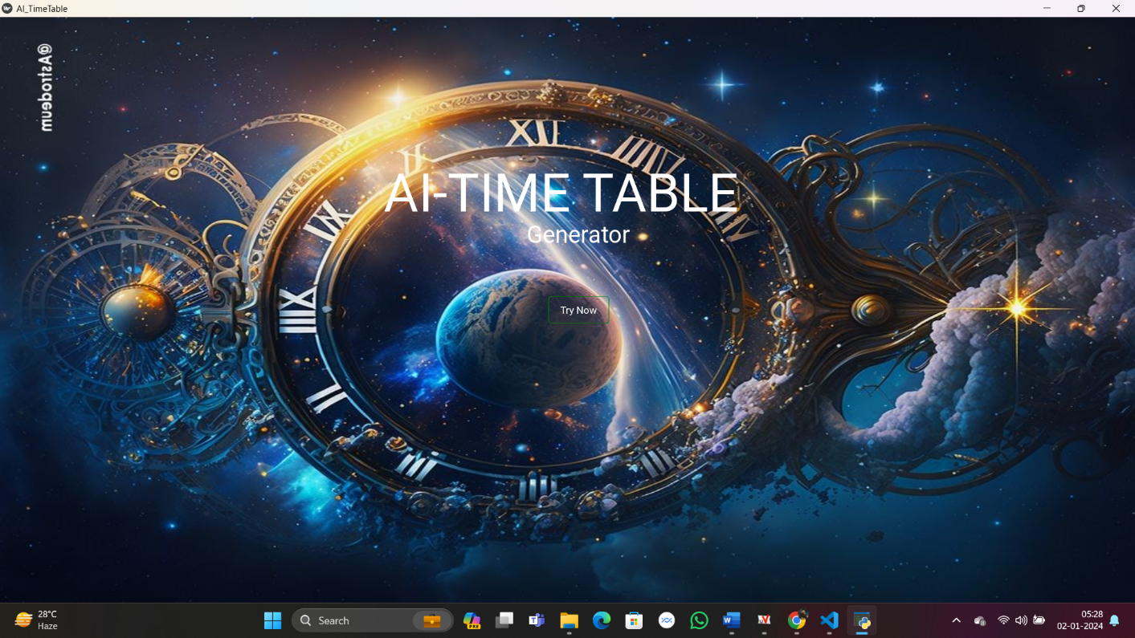

**Second Screen:**

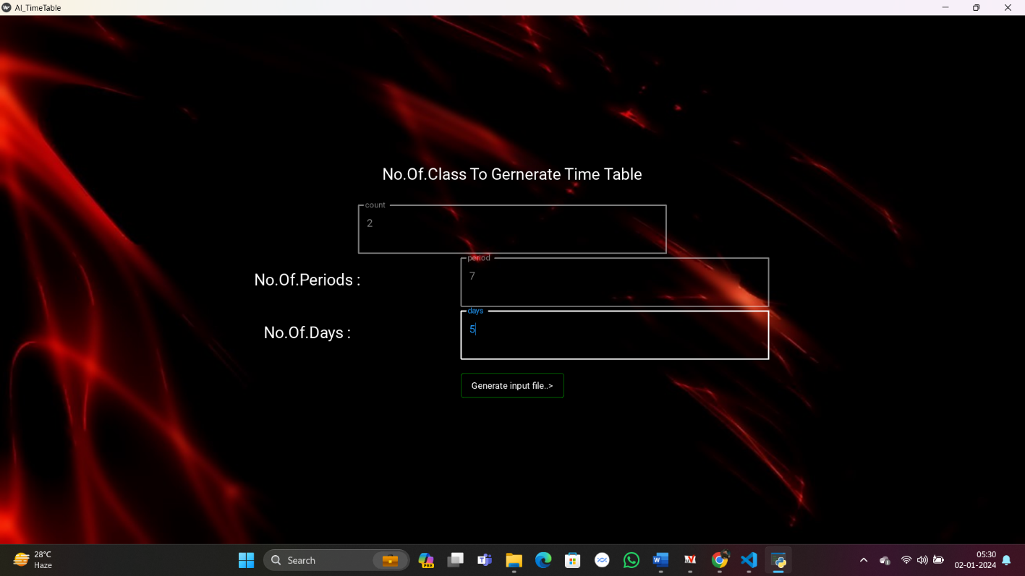

**Third Screen:**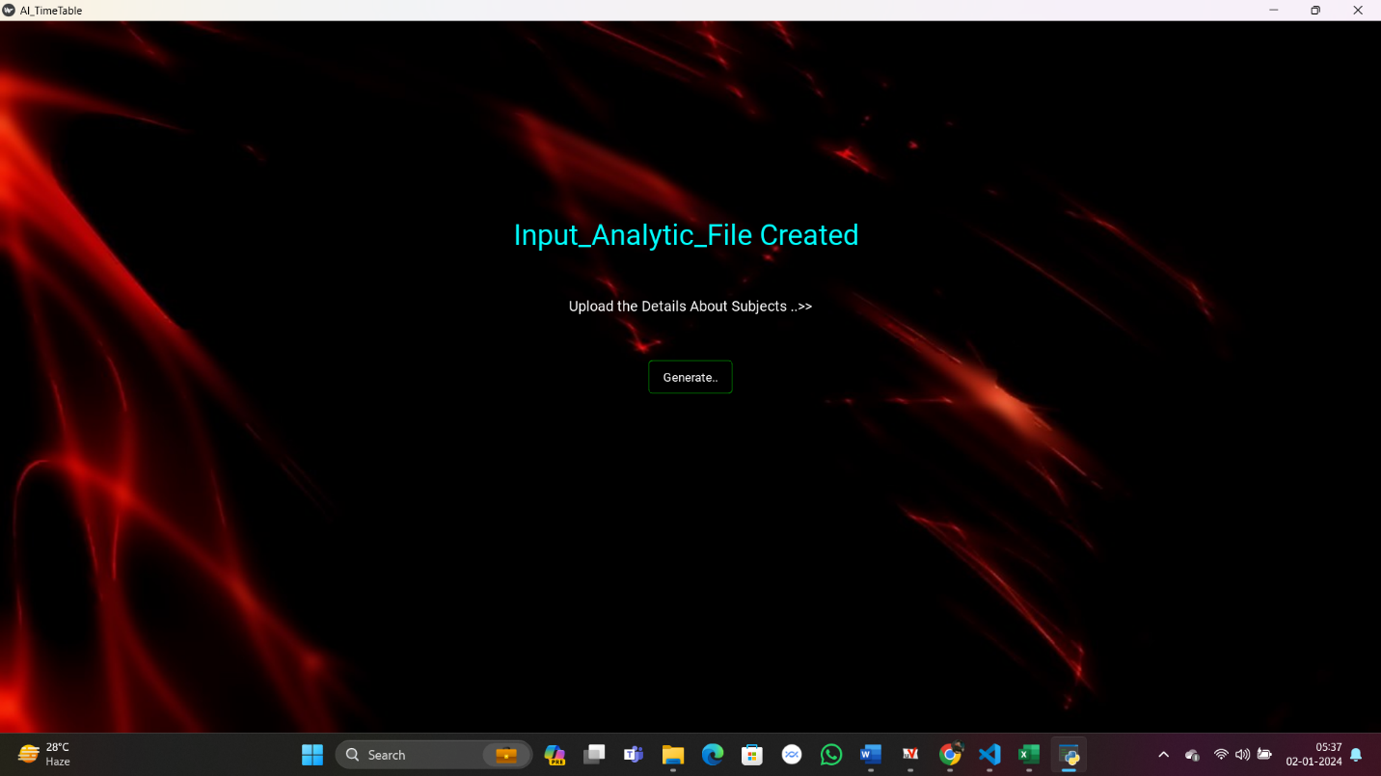

**Input Analytic file:**

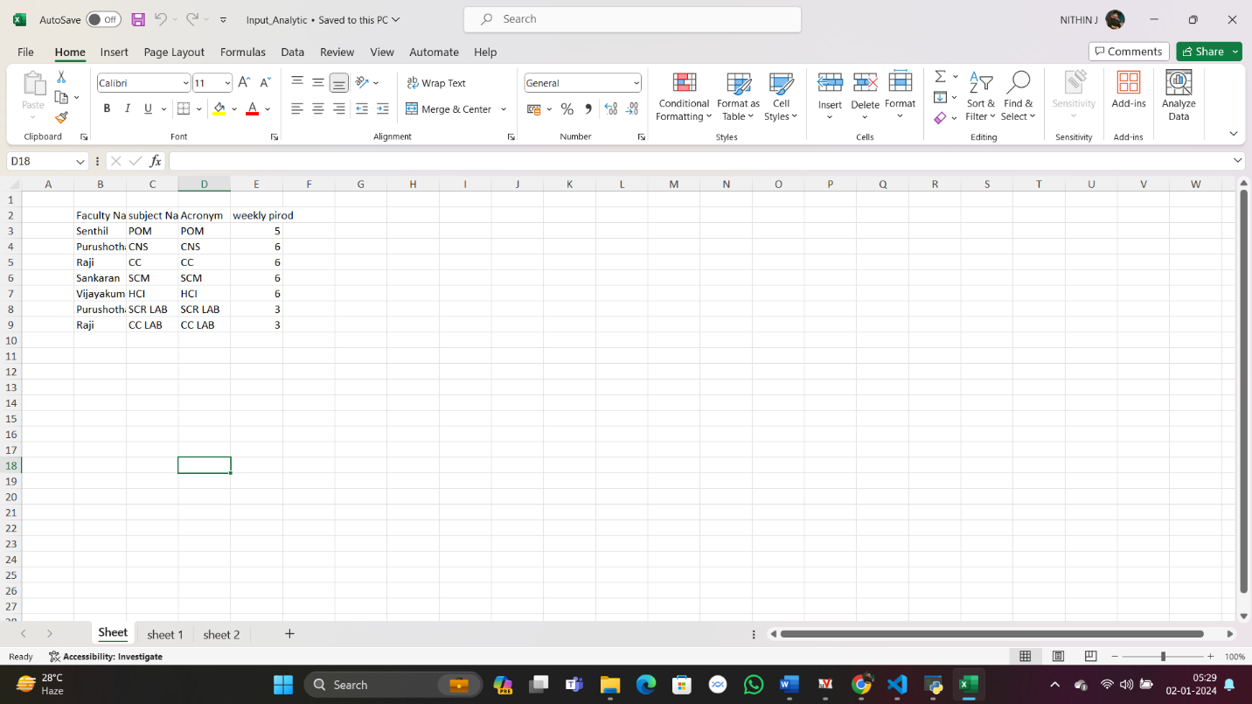

**Forth Screen:**

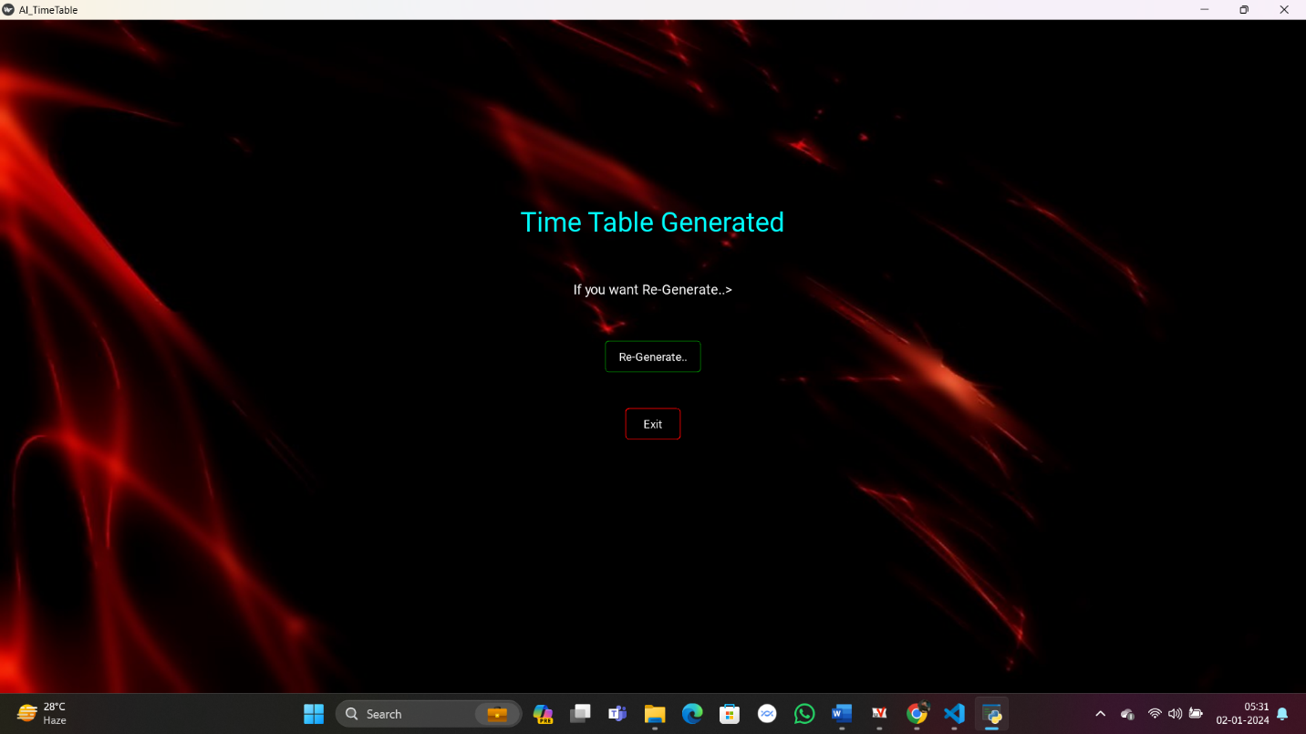

**Output.xlsx**

**CHAPTER 10**

**CONCLUSION**

In conclusion, the AI-powered timetable generator presents a transformative solution to the traditional and often complex process of scheduling. By harnessing the capabilities of artificial intelligence, this system efficiently optimizes resource allocation, minimizes conflicts, and enhances overall scheduling accuracy. The implementation of AI in timetable generation not only streamlines the workflow for educational institutions but also contributes to improved efficiency, reduced manual workload, and increased satisfaction among stakeholders.The AI timetable generator considers various constraints and preferences, providing a balanced and customized schedule that aligns with the diverse needs of students, teachers, and administrators. Its ability to adapt to changes in real-time, consider multiple parameters simultaneously, and continuously learn and refine its scheduling approach positions it as a valuable tool for educational institutions seeking a modern and adaptive solution.Furthermore, the use of AI in timetable generation fosters a data-driven decision-making process, allowing institutions to analyze historical scheduling data, identify patterns, and make informed adjustments for future iterations. This iterative learning process contributes to ongoing improvements in the efficiency and effectiveness of the scheduling system.While the implementation of AI in timetable generation presents numerous benefits, it is essential to address potential challenges, such as data privacy concerns, algorithmic biases, and the need for ongoing system monitoring and updates. Striking a balance between technological innovation and ethical considerations is crucial for the successful integration of AI in educational processes.

**CHAPTER 11**

**REFERENCES**

1. M. D. Boomija, R. Ambika, J. Sandhiya, P. Jayashree, “Smart and Dynamic Timetable Generator”, International Journal for Research in Applied Science and Engineering Technology, March 2019.
2. V. Abhinaya, K. Sahithi, K. Akaanksha, “Online Application of Automatic Timetable generator”, International Research Journal of Engineering and Technology, February 2019.
3. Akshay Puttaswamy, H. M. Arshad Ali Khan, Chandan S. V, Parkavi. A, “A Study on Automatic Timetable Generator”, International Journal of Science and Innovative Engineering and Technology, May 2019.
4. Adithya R Pai, Ashwitha S, Raksha Shetty, Geethalaxmi, “Automated college timetable generator”, International Journal of Scientific & Engineering Research, vol. 9, no. 4, April 2018.
5. Saritha M, Pranav Kiran Vaze, Pradeep, Mahesh NR, “Automatic time table generator”, International Journal of Advanced Research in Computer Science and Software Engineering, May 2017.
6. Dipesh Mittal, Hiral Doshi, Mohammed Sunasra, Renuka Nagpure, “Automatic Timetable Generator using Genetic Algorithm”, International Journal of Advanced Research in Computer and Communication Engineering, February 2015.
7. Anuja Chowdhary, Priyanka Kakde, Shruti Dhoke, Sonali Ingle, Rupal Rushiya, Dinesh Gawande “Timetable Generation System,” IJCSMC, vol. 3, no. 2, February 2014